Ealing, Harrow Libraries

Shared Service
Contract Governance and SLA Agreement

Author: David Lillicrap
Version: 01
Date: 04/01/2013
CONFIDENTIAL
DRAFT
Distribution List
Name | Role | Action Required  (Sign-off / Feed Back)
Keith Townsend | Ealing Council - Executive Director Customer Services | Sign-Off
Paul Najsarek | Harrow Council – Corporate Director of Community, Health and Wellbeing | Sign-Off
Marianne Locke | Harrow Council -  Divisional Director Community & Culture | Sign-Off
Alison Reynolds | Ealing Council - Director of Customer Services | Sign-Off
Ian McNicol | Harrow Council – Interim Head of Libraries and Cultural Services | Feed Back
Tim Bryan | Harrow Council - Head of Libraries and Leisure | Feed Back
Carole Stewart | Ealing Council - Assistant Director, Arts, Heritage and Libraries | Feed Back
Emily O’Hare | Ealing Council - Policy Officer | Feed Back

Version control
Issue No. | Date | Author | Reason for Amendment
01 | 08/01/2013 | David Lillicrap | Draft for Review

Table of contents
1 Introduction 4
1.1 Introduction 4
1.2 Purpose 4
1.3 Scope 4
The Agreement 6
1.4 Agreement Overview 6
1.5 Periodic review of SLA 6
1.6 Individual Borough Sovereignty 6
1.7 Responsibilities of Head of Service / Assistant Director (Lead Officer) 6
2 Service AGREEMENTS 8
2.1 Service Agreement - Libraries 8
2.2 Resourcing 11
2.3 Payment Schedule 11
Appendix A – Facilities in SCope of the SLA 12
Appendix C – StrUCture Charts 13

Introduction

Introduction
In order to deliver the maximum cash benefit from a move to single contracts for Leisure provision across the three boroughs; and Libraries Provision across Harrow and Ealing; the options for Sharing common functions have been considered throughout the development of the joint procurement.
An options paper in March 2012 identified a recommended option for operational management of the Joint Contracts, with current Heads of Service remaining in place, with each borough managing a functional specialism(s) for other boroughs. Steering committee agreed that this recommended approach should be developed further to a formal proposal on the structure to support the shared model.
Following further development, the following allocation of accountabilities was proposed:
- Ealing to lead on Leisure Contract Management, across three boroughs
- Each borough will retain responsibility for their own sports development teams.
- Harrow to lead on Libraries Contract Management for Ealing and Harrow (Subject to on-going review)
This proposal was presented to Steering Committee in July 2012, they agreed that this structure will be recommended to Cabinets and Executives in February and March 2013, alongside the recommended decision on successful suppliers for the Leisure and Libraries Contracts.
This paper documents the Service Level Agreement (SLA), between the boroughs that will underpin the Lead Borough management of the Libraries Contractor.

Purpose
The purpose of this document is to ensure that all required elements are in place to provide effective shared contract management of the Libraries Contractor.
The goal is that the Senior Officer in the three boroughs agree the documented SLAs as the agreed service provision between the boroughs.
The objectives of the SLA are to:
- Provide a clear and unambiguous statement of what the Customer Boroughs can expect from the Service Providing Borough
- Present measures of the Services that will be provided to ensure that performance to the SLA can be tested
- Ensure that there is a match between the expected services and the planned service delivery

Scope
The scope of the SLA includes the management of the contract(s) to provide Libraries services. A full list of in scope facilities is listed in Appendix A.
The scope of this options review excludes the following:
- Harrow Music Services
- Harrow Heritage
- Harrow Arts Centre
- Ealing Adults Learning
- Pitzhanger House and Gallery
- Ealing Arts and Heritage

The Agreement

Agreement Overview
This agreement represents a Service Level Agreement (SLA), between the following Parties:
- London Borough of Harrow (Service Provider) and London Borough of Ealing (Customer) for provision of Contract Management for Libraries Services
The role of the Service Provider Borough is detailed in the Service Level section, below.

Periodic review of SLA
The SLA will be reviewed annually, as part of the annual contract review processes. The service level described, anticipates a higher level of interaction with the contractor in the first year of operation of the contract.

Individual Borough Sovereignty
At Member and Senior Officer level, policy and strategic matters will remain with each borough. The level of Member engagement with the responsible officer and contractors will remain unchanged, this is captured in the Service Agreements, below.

Responsibilities of Head of Service / Assistant Director (Lead Officer)
The responsible officers in both boroughs will retain ownership of the strategic direction of the Boroughs Library Services.
In both boroughs, The Heads of Service / Assistant Directors have responsibilities that are broader than the scope of the Libraries contract. The Heads of Service / Assistant Directors will retain the responsibility as Lead Officer for Libraries for their borough; owning the subject matter strategy for their service.
The Customer Borough will ensure that all staff and facilities are handed over to the Contractor on first day of contract; and will resolve any Staff Transfer issues identified after go-live.
The SLA is owned in the Customer Borough at Head of Service Level, any additional dissemination of information to Directors, Board and Cabinet / Executive; will continue to be undertaken in a similar manner to current processes and procedures.

Ealing Responsibilities with Respect to Inter-serve
While Ealing’s contractual relationship with Inter-serve is in place. Ealing will provide access to the Inter-serve Client Management resource to the Service Provider Borough.

Development of Strategic Partnering
The aim of the Libraries Contract is wider than simple business as usual running of Libraries. Throughout the period of the contract the Heads of Service / Assistant Directors, will expect the Libraries Contractor to adapt to the boroughs’ evolving requirements and strategy for Libraries.
Work to evolve the contractual relationship, to ensure on-going innovation in the delivery of library service will be the responsibility of the Service Provider, acting on behalf of the Customer Borough.

Contract Mobilisation
It is anticipated that during the first few months of the new contractual arrangements being in place, there will be additional resources needed to manage exceptions and incidents. This additional resourcing is outside of the scope of this SLA and the additional resources will be provided by the impacted borough. Arrangements for the Contract Mobilisation are covered in the implementation plan.

Service AGREEMENTS

Service Agreement - Libraries
The following Table Details the services that will be provided by the London Borough of Harrow for the Libraries Contract.

Service Area | Service Level Description | KPI
Meetings with Supplier | Monthly Business review (MBR) Meetings, including Lead Officer from Customer Borough and borough partner (Ealing)  Review of performance to include, but not be limited to utilities usage data and efforts to control utilities use, staff training, and expenditure on stock and performance targets agreed within the service contract  Review of change control proposals and actions  Annual Contract Meeting will be held involving Portfolio Holders and Lead Officers | All MBRs / Annual reviews conducted  Papers will be circulated at least 5 working days in advance and draft minutes published within 5 working days.
Review of Supplier Metrics and management information | Analyse supplier metrics and provide commentary and report to Head of Service of Customer Borough on a monthly basis | Analysis provided to Head of Service at least 5 working days prior to the MBR meeting
Management of Mobilisation process, staffing and facilities | Outstanding and on-going mobilisation issues and actions The Service Provider will manage the completion of these activities; however, the boroughs will provide additional resources for mobilisation (pre and post contract start date) | N/A
Site Visits | Undertake site visits monthly, and review sites, against checklist (TBC) | Record of 12 visits per facility
Maintenance Assurance | Ensure maintenance issues are handled in a timely manner and do not affect opening the service to customers; and minimisation of impact on service quality during times where unavoidable rectification has to happen during opening hours. to the public. In particular, if either borough retains any maintenance functions, to ensure smooth relationships between maintenance provider and service provider | TBC
Review of Supplier Metrics and management information | Analyse supplier metrics and provide commentary and report to Head of Service of Customer Borough on a monthly basis | Analysis provided to Head of Service at least 5 working days prior to the MBR meeting
Reporting to Head of Service | Monthly report on performance to Senior Management in digest format with summarised headlines for individual borough service. This will need to highlight trends and see if they are localised or replicated across both areas. This will be in a standardised format reporting on visits, issues, IT usage, events, partnership contact, failure to open/provide service and reasons for occurrences IT outages, maintenance issues, customer complaints, number of member complaints dealt with | Report provided to Head of Service at least 5 working days prior to the MBR meeting
Preparation of Reports for members | From time to time during the contract,  Actual report preparation in plain English and presentation to be undertaken by Customer Head of Service | Initially report bi-annually to members (moving to annually after Year 1).
Scrutiny reports | Prepare Scrutiny reports for Customer Head of Service  Attend, and respond as required, Scrutiny meetings at Customer site | 1st Draft Scrutiny report provided 10 working days before 1st Submission date.
Rectification | In the event of consistent under-performance by the contractor, to develop a performance improvement plan and manage the Contractor through to completion of the improvement plan.  Trouble shoot, co-ordinate and resolve blockages and obstacles to contract delivery on client side to ensure delivery of contract | N/A
Assurance | Ensure that H&S certificates are in place and not expired  Fire certificates in place and not expired  Gas and Electricity safety certificates in place and not expired  ICT Security (covering firewalls and anti-virus) software maintained to most up to version | 100% of required certificates in place
Incident Management | In the event of an incident, to provide on-site support to resolve the incident within 1 hour, and to manage to resolution  Provide hourly verbal updates to the Head of Service of the Customer Borough | 100% Adherence to Local Incident Management Procedures
Member Enquiries | Research the enquiry and provide a draft response to the Senior Officer of the relevant borough.  Monthly response to questions from Full Council | Provide draft response within 5 working days  Questions responded to in 2 working days
Customer Complaints | Investigate the complaint and provide a draft response to the Senior Officer of the relevant borough. | 100% Adherence to Local Complaints Policy
Partnerships third parties | To ensure that the service provider maintains and develops existing partnerships e.g. health, JobCentre Plus, universities, schools and colleges.  Ensure that service provider links in to relevant borough cultural calendar e.g. Summer Reading Challenge, Adult Learner’s Week, Black History Month, Under One Sky. | N/A

Resourcing

Specialism | Current Resources | Planned Resourcing
Libraries Contract Management | None | - 2 x Contract Officer – one to lead on Ealing Libraries, one for Harrow Libraries.

Payment Schedule
The following table outlines the payments between Boroughs

Service Provided | Description | Payment
Contract Management of Library Services Contract to Ealing | 13 x Libraries | TBC

Appendix A – Facilities in SCope of the SLA
All Ealing and Harrow libraries and back office services (including reader development, stock management, Ealing Local History & Archive Services, Home Library Services, St Bernard’s Hospital Library Service, Harrow Schools Library Service)

Ealing Council – 13 libraries:
- Central Library (Ealing Broadway Centre)
- Greenford Library
- Southall Library (to be relocated by 2014 to Dominion Arts & Community Centre)
- West Ealing Library
- Hanwell Library (being refurbished in 2012)
- Northolt Leisure Centre Library
- Jubilee Gardens Library (co-located with a Health Centre)
- Northfields Library
- Northolt Library
- Perivale Library (being refurbished in 2012)
- Pitshanger Library
- Wood End Library (co-located with a Children’s Centre)
- Acton Library (to be relocated in 2014 to the new Acton Town Hall)

Harrow Council – 11 libraries:
- Gayton Library
- Civic Centre Reference Library
- Bob Lawrence Library
- Hatch End Library
- Kenton Library
- North Harrow Library
- Pinner Library
- Rayner’s Lane Library
- Roxeth Library
- Stanmore Library
- Wealdstone Library (co-located with a Health Centre)

Appendix B – StrUCture Charts
B1 Ealing Libraries Structure
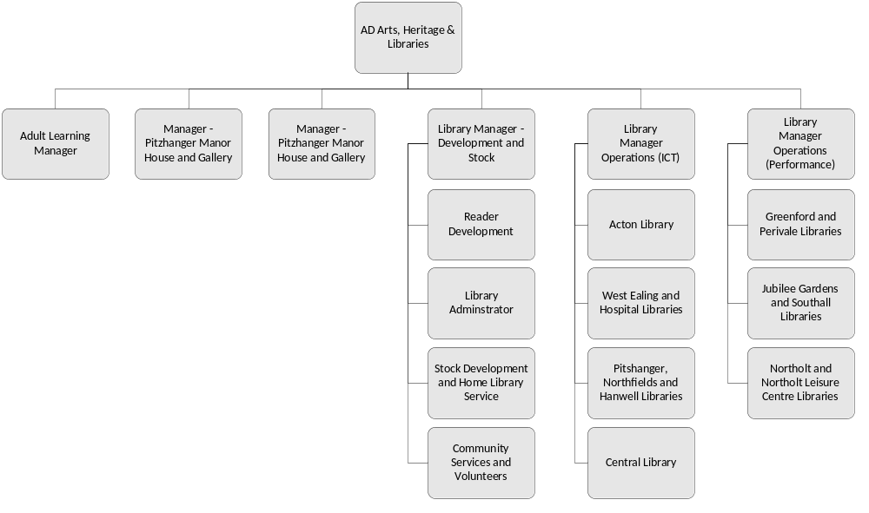
B2 Harrow Libraries Structure (Includes Accountability for Leisure)


